音樂課(音樂家)
認識舒伯特
連結: https://www.youtube.com/watch?v=fbHqmCrwnvg
請小朋友點選(複製)連結觀看舒伯特的小故事。

音樂欣賞
- 軍隊進行曲https://www.youtube.com/watch?v=3e6tDNMNhY0
- 野玫瑰
https://www.youtube.com/watch?v=7IQ9c8DbR1A
- 鱒魚
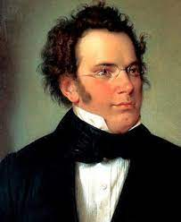
https://www.youtube.com/watch?v=Qh155AoL_Go
大家好~我就是鼎鼎大名的舒伯特先生!!
希望我的作品大家會喜歡 =)

